Account Sign In and Recovery

Software Requirement Specification V2.1

Contents

Introduction **3**

Purpose 3

Scope 3

**Requirements** **4**

Footer Items 4

Language Dropdown 4

Help Link 4

Privacy Link 4

Terms Link 4

Forms 4

Sign In Initial Form 4

Account Chooser Form 5

Sign In Password Form 7

Account Recovery Forms 8

Forgot email 9

Last Password 9

Phone Verification Code Form 10

Email Verification Code Form 11

Code Verification Form 11

Session Time-Out Form 11

Formats and Fields Constraints 12

Email Fields 12

Password 13

G-Code 13

System Logs 13

Forms Language 13

Design constraints 13

Logo 13

Text Fields 13

Error Messages 13

Fonts 14

Forms Size 14

Buttons 14

Software System Attributes **14**

Deliverables **14**

Design Documents 14

Backend Code 14

Users Database 14

User Interface 14

UAT Report 14

User Training 14

# Introduction

## Purpose

The purpose of this document is to provide an example for software requirements description documents, to be used as material for testing analysis by Sprints ETB Course.

## Scope

The document describes the Google Account Sign In and Recovery website Module as well as the system specifications and attributes.

# Requirements

## Footer Items (what is the footer items?)

### Language Dropdown (how many language will be availed?)

### Help Link TC

It navigates to the Help page, considering the chosen Language.

### [Privacy](https://accounts.google.com/TOS?loc=EG&hl=en&privacy=true) Link TC

It navigates to the Privacy & Terms page / Privacy Policy tab, considering the chosen Language.

### [Terms](https://accounts.google.com/TOS?loc=EG&hl=en) Link TC

It navigates to the Privacy & Terms page / Conditions tab, considering the chosen Language.

## Forms

### Sign In Initial Form UI TCs

This is the first Form that opens for a user who wants to login to the system.

**Form Items:**

1. Title: Sign IN
2. Sub-Title: Use your Google Account
3. A text field for email or Phone.
4. A Forgot email link, which navigates to “Account Recovery / Find Your Email” Form.
5. A label with “Not your computer? Use Guest mode to sign in privately.” And “[Learn more](https://support.google.com/chrome/answer/6130773?hl=en)” link that navigates to Help Page / Answer to Question “Browse Chrome as a guest” page considering the selected language.
6. “Create Account” Link (Not for this phase.)
7. Button with text: “Next” that navigates to “Password” Form, in case the email is correct.

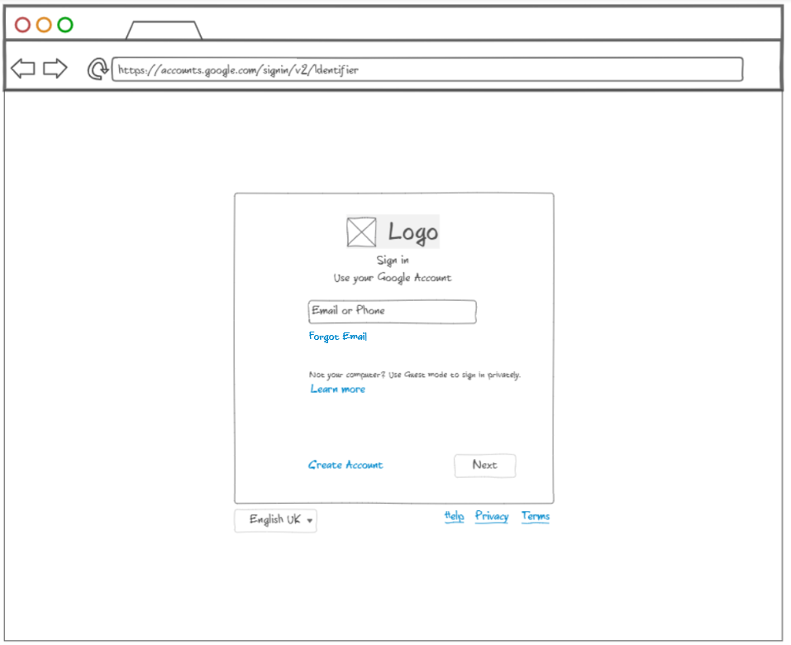

**Functionality: Test Scenario**

User is asked here to submit his registered account email or phone number, the email should be written in the true format as in 2.3.1, then when the user clicks [Next] he should be redirected to “Sign In Password” Form.

Users can use navigation to this form although they already signed in, to sign in with different email.

TC

In case that the user submits an already signed in mail, he should sign in directly without navigation to Password form.

### Account Chooser Form Test scenario

TC

This form should show the google accounts list that have been stored in the used browser.

**Form Items:**

1. Title: Choose An Account
2. Clickable Account Item:
   1. User profile image
   2. First and Last Name right side the image
   3. Email in smaller font  
      **Note**: don’t show the email nor the image in case the stored account is a phone.
   4. Sign out Label at the top right side of the item row (If the account is signed out)
3. “Use another Account” Option: under the accounts list, displayed like other accounts with default user icon.

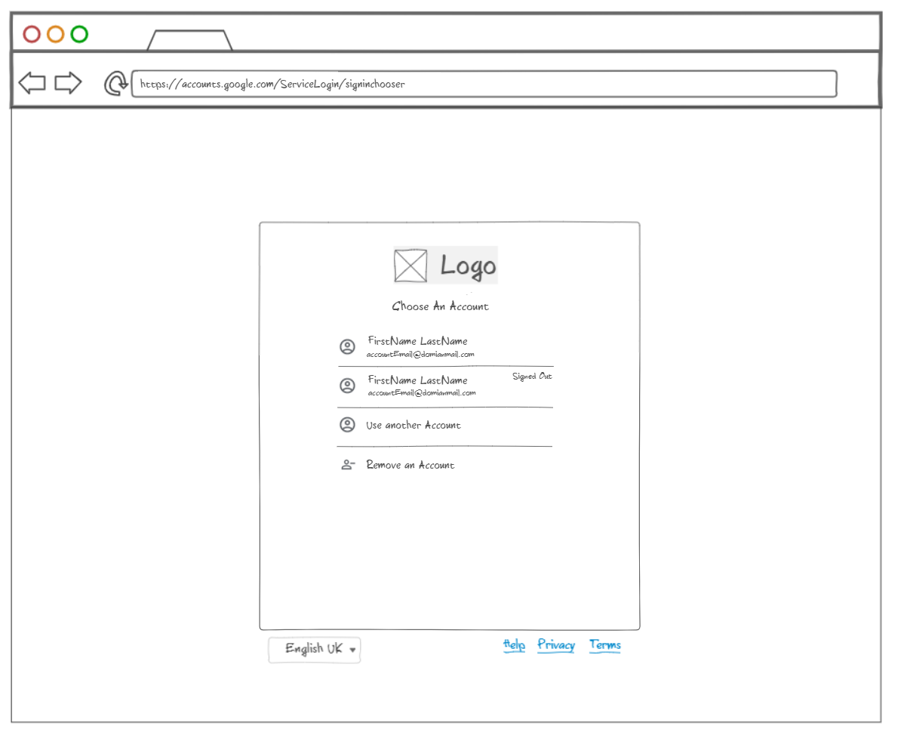

**Functionality: Test Scenario**

This form can be opened if there is a stored account(s) and the user tries to sign in with a different account. For example, when:

* A User clicked on “Accounts” Dropdown in the “Sign in Password” Form. TC
* A Logged in User clicked on “User Menu” 🡪 “Add another Account”
* A user is resetting his password from “Password Reset” Form, and clicked “Accounts” Dropdown.

User can select one of the stored accounts he signed in before. If an account is signed in, No password should be required from the user, he should sign in directly. If not, he should be redirected to “Sign In Initial” Form to submit his Password.

He also can remove a stored account, by clicking on “Remove an Account” option, the Remove icon beside any listed account.

Removing an account: Alert dialog should show in front of the page with title “Remove account?” which can be closed by clicking outside the dialog. One option should appear, which is [Yes, Remove].

### Sign In Password Form

This form is one password field form that allows the user to Sign in after submitting his true Password.

Stored accounts: are those who have successful Sign in the used browser. Not necessarily a signed in accounts, but they were not removed from stored accounts list in the current Form.

**Form Items:**

1. Title: [Welcome] or [Hi, “User First Name”]
2. Accounts Dropdown (Last Email or Phone)
3. Password Field
4. “Show Password” Checkbox
5. “Forgot Password” Link
6. [Next] Button

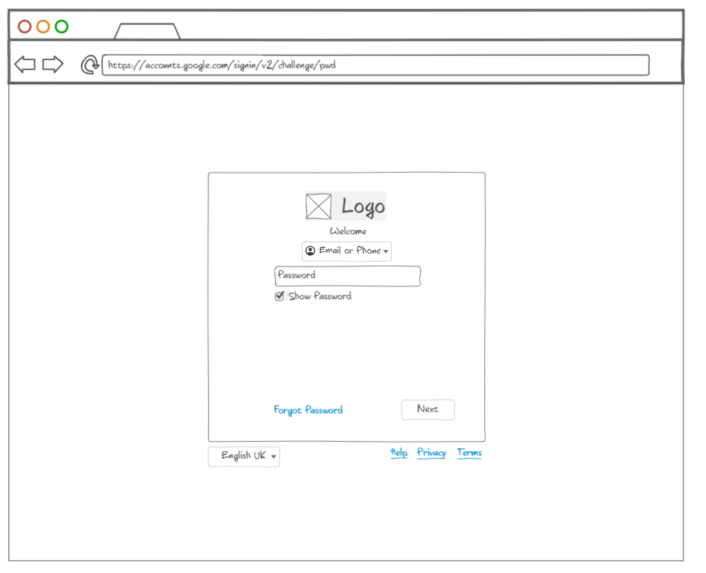

**Functionality:**

This form can be opened if there is a stored account(s), when:

1. A User submitted the correct email for his/her from “Sign in Initial” Form.
2. A User selected a signed out account from “Account Chooser” Form.

User can submit his Password here Then Click [Next] button to have successful Login.

Password field should follow the 2.3.3 format.

Show Password Checkbox allows the user to see his written Password. Default state: Unchecked.

A Forgot Password link navigates to “Account Recovery / Last Password Form” Form.

### Account Recovery Forms

Account Recovery forms allow the users to recover their accounts by different secure options. They depend on account items that have been submitted by the user while his registration, like: first and Last Names, recovery email, phone number …etc. The following are the different ways forms.

#### Forgot email (missing the rest of wrong phone number)

This Form allows the user to recover his account by submitting his account recovery email or Phone number.

In case the user submits wrong email format or wrong phone number, error message should display: “Enter a valid email or phone number”

In case the user submits a non-existing email, error message should display: “Couldn't find your Google Account. Try using your email address instead”

If the user submitted a correct email, he should be asked to submit his account First and Last Names, If Not Valid, “No account found” message should show. If valid, he should be redirected to “Email Verification Code” Form with text: “Google will send a verification code to:'' his submitted recovery email. Once he clicks the [Send] button, the user should receive a verification Code in his mailbox with a message. Verification code should be 6 digits and can be used in 1 hour.

User then is directed to “Code Verification” Form, when he copies the verification code to the form, he should be directed to “Sign-In Password” Form Successfully. What is the process in case of wrong verification code?

#### Last Password

Last Password Option allows the user to submit an old password, to recover his account. Below is the first form for the user scenario.

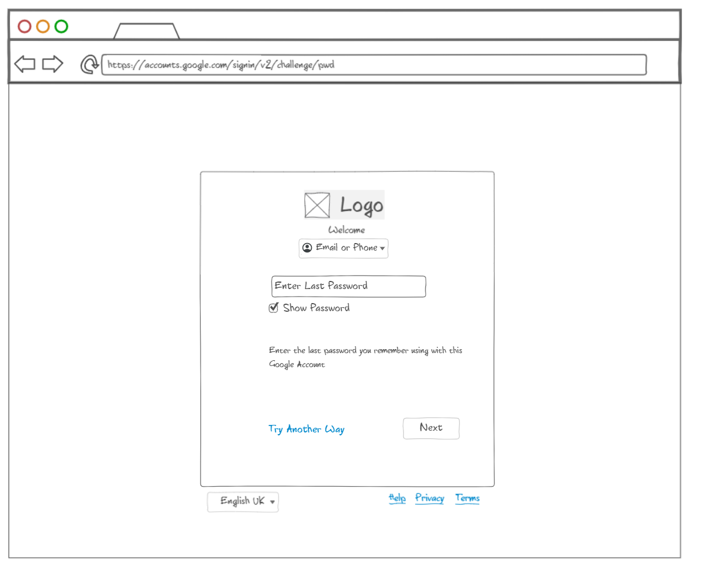

Once the user submits a correct old Password, he should be redirected to one more user verification method, and then he should be allowed to change his password.

If the user is submitted the current correct password, A success message should display: “Title: Success - you are signed in now.” Body: “You entered your current password, so you can continue to your Google Account. You can still change your password if you want.” And the Change Password option should display. In case he clicks it, he should be asked to enter the same current password one more time for verification.

#### Phone Verification Code Form

This option sends a verification G-Code for the user's phone. It opens when the user submitted his recovery Phone number.

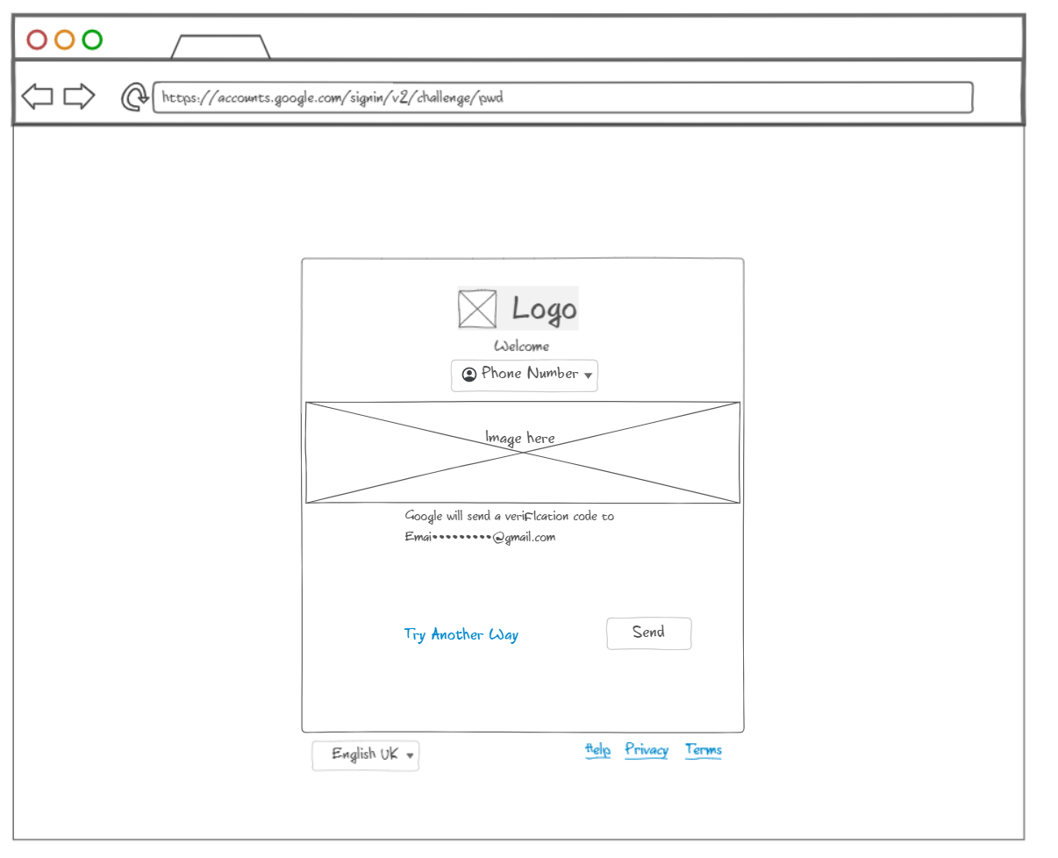

#### Email Verification Code Form

This form sends a verification G-Code for the user's e-mail. It opens when the user submitted his recovery email and true First and Last Names.

#### Code Verification Form

This Form allows the user to submit a verification code for email or password recovery processes.

### Session Time-Out Form

This form displays when the user is inactive for more than 15 minutes.

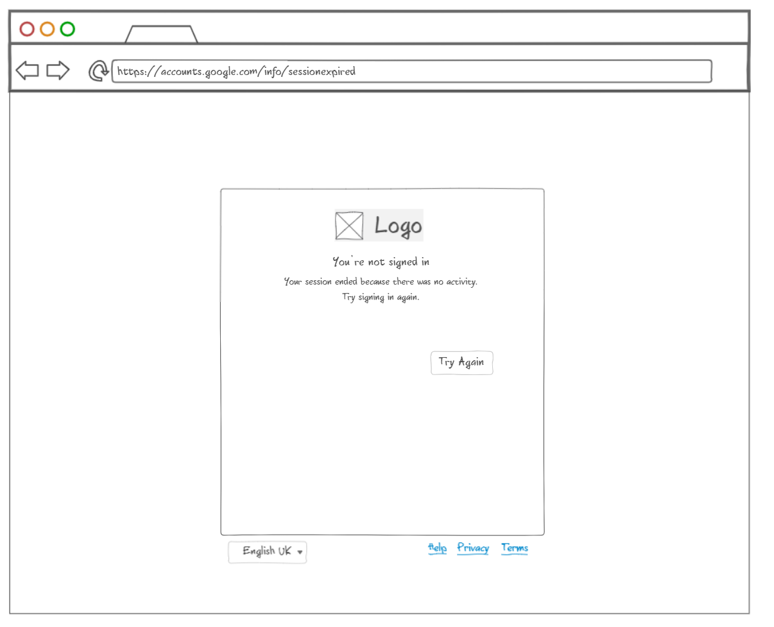

**Items:**

Title: You're not signed in

Sub-title: Your session ended because there was no activity. Try signing in again.

Button: Try Again

**Functionality:**

Only the “Try Again” button, should return to the recent active form.

## Formats and Fields Constraints

### Email Fields

Email format should be like “string@string.str”, If the user submitted a different format, an error message should display under the field: “Wrong Google Account”. If the email does NOT Exist, the error message should be: “Couldn't find your Google Account”.

For Account Recovery mail field, If the submitted mail doesn’t exist, error message should be: “Please enter a valid email or phone number”

Email fields should support email or phone, except with mail recovery fields.

Email fields should allow any character only while writing, however in clicking [Next] for example, an error message should display for invalid data and it should Not proceed.

### acc

### Password

Password fields should be masked by default and NOT allowable for copies.

### G-Code

G-Code Format should start with “G hyphen” in the verification mails and text messages followed by 5 random digits. G-Code should expire if used one time and after 10 minutes of receiving. They should be random and new codes.

## System Logs

Successful Logins and Password Change trials should be stored in a log system with the following attributes:

1. User ID
2. Operation Name
3. Success Status
4. Operation Time

## Forms Language

All Forms languages should be the chosen language from footer language dropdown. Default chosen language of the languages dropdown is set according to the location of the user browsing the site.

## Design constraints

### Logo

Every form should have the Google Logo at the top of the form.

### Text Fields

Every Text Field should provide a placeholder text for what is required from the user, e.g. Email or Phone, Once the user clicks or navigate to the field, the PlaceHolder text should move to the top border line of the text field.

### Error Messages

Error Messages happens, when a user submit non-existing account, invalid format, wrong password, wrong recovery data …etc.

Error messages should display under the input field in Red font with an error icon. Input field should be red until user submits correct data.

### Fonts

All Fonts should be as default: “Roboto” then “Sans Font” if the first not renders.

### Forms Size

Size: Height = fit to components * width 500px

### Buttons

All buttons should have: The color: “#4583ee” and The Size: should fit to text with 24px Padding.

# Software System Attributes

|  |  |  |
| --- | --- | --- |
|  | **Items Names** | **Version** |
| Windows Browsers` | Chrome | 87.0 and higher |
| Firefox | 84.0.1 and higher |
| Internet Explorer | 11.0 |
| Mobile Browsers | Android Google Chrome | Latest |
| IOS Safari | Latest |

# Deliverables

## Design Documents

## Backend Code

## Users Database

## User Interface

## UAT Report

## User Training